**Darren Nicholas Suwito**

**2702312442**

**Home Page**

When opening the page, would direct the user to the main page:

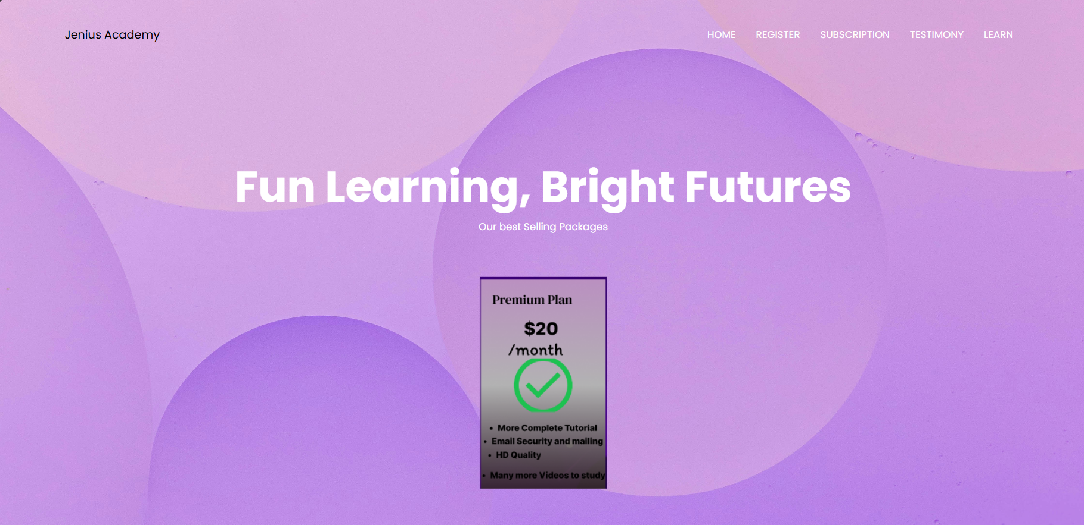

There are a navbar that can be clicked and navigate the user to the section they want to see.

The user can click on the Home that can directs the user to the main page

User can click on:

“Subscribe” to the subscription page.

“Testimony” to the testimony page

“Learn” to the learning page.

“Register” button to the register page

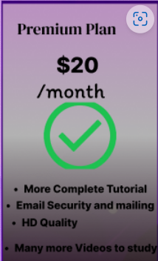

The user also greeted with our most recommended plan for beginners which is the Premium Plan and can give many benefits for the user.

**Registration Page:**

By clicking on any of the registration button, the user is greeted with the registration page.

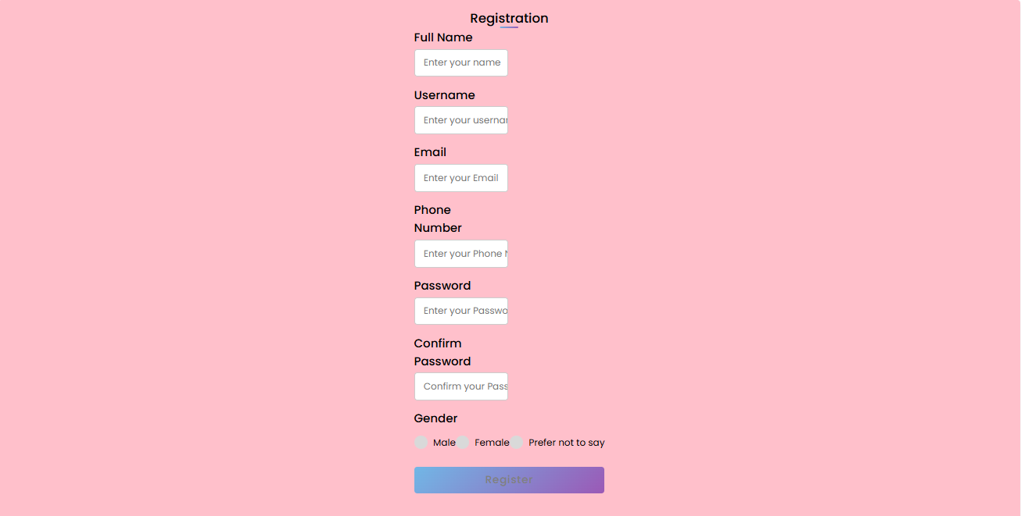

The user is required to feel all of this, if not then the registration wouldn’t be completed, and an alert will pop out for its respective empty input boxes

The user can register by clicking on the “register” button below

The registration requires:

The Name, Surname, Email, Password and Confirming their password.

**Subscription Page:**

In the subscription page, the user are going to see many features and options:

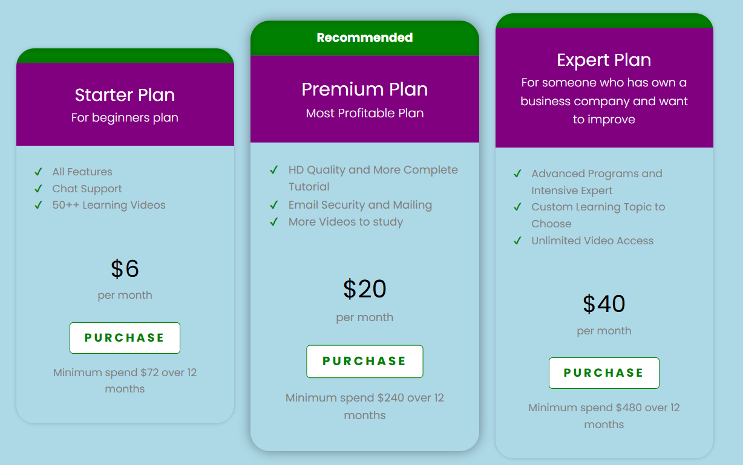

From this screenshot, we know that there are 3 main options that can be chose by the user. However, the recommended plan for beginner is to use the premium plan because the price is quite rational and can give many impact to their skills.

**Testimony Page:**

In the testimony page, the user is greeted:

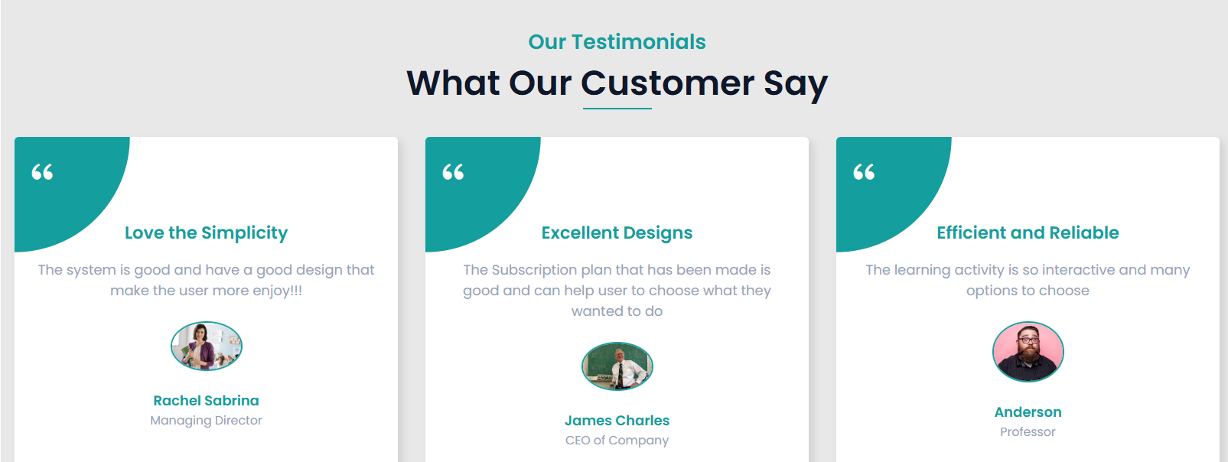

It features the profile pictures, the name, and the testimony of the users.

**Learn Page:**

In the learn page, the user is greeted with:

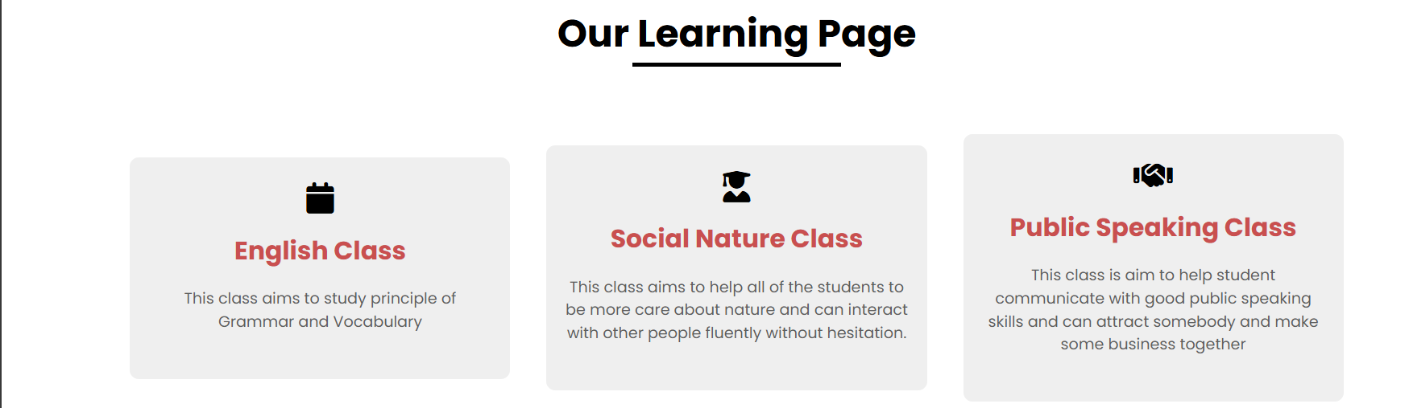

This are three type of classes that can be chose by the user and all of them have their own different benefits from the others.



There is also an animation video about learning concepts that can be use by the user to boost their educational skills and can give a great impact for them in the future.

**References for Assets Used:**

Images:

testimony.1 from: https://th.bing.com/th/id/OIP.2Ecc2kJaDoiau98cs8wETgHaE8?rs=1&pid=ImgDetMain

testimony.2 from : C:\Users\darre\Downloads\prof.jpg

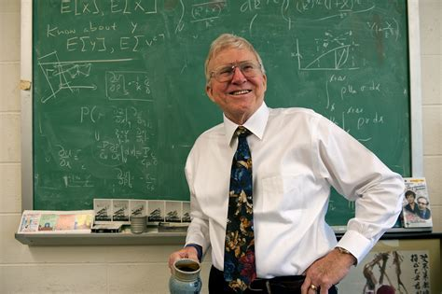

testimony.3 from "C:\Users\darre\Downloads\testimony.png"



Videos:

video from https://youtu.be/8lvkJhXnEZk?si=ZJoJUFSdinfHLypo